AI statement:
In these bones questions, I used AI tools (Gemini) as a learning assistant. Specifically, I used AI to:
1. Help me better understand the questions requirements.
2. Get suggestions on which points to choose
3. Optimize my written text answers for better clarity.

Bonus Question (a)
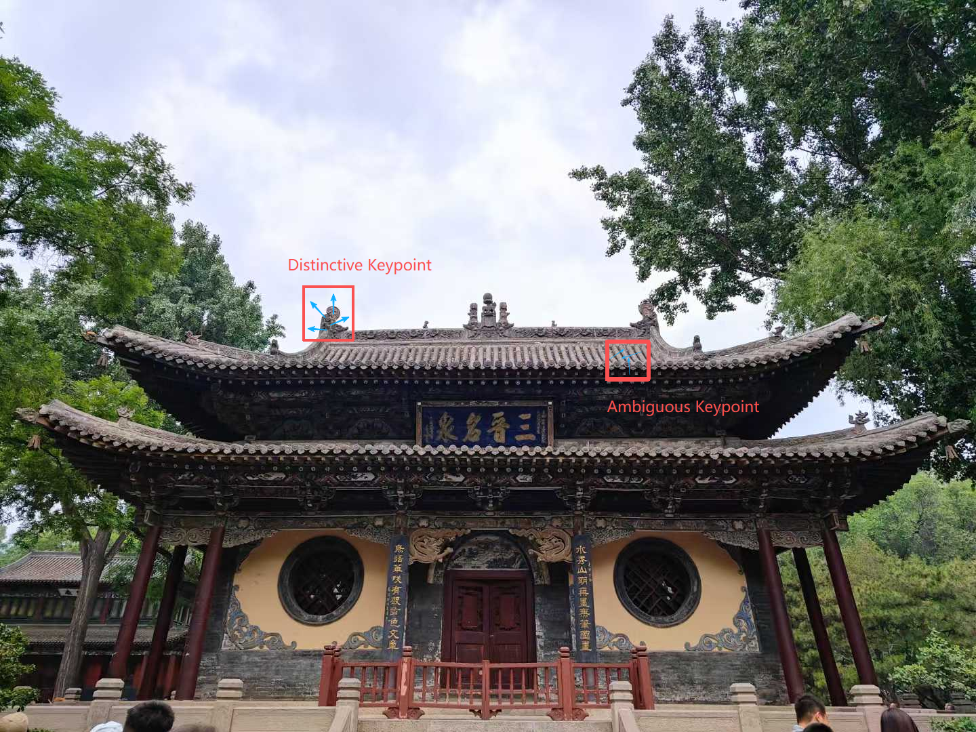
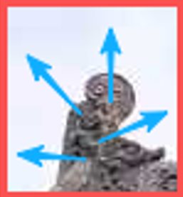
Distinctive Point: This specific corner has a unique angle and is surrounded by a smooth, featureless sky. Its 128-dimensional descriptor will capture a very specific gradient distribution that does not repeat anywhere else in the image, making it highly unique for matching.
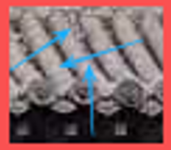
Ambiguous Point: While it is a valid corner/edge with strong gradients, it is part of a highly repetitive texture (the roof tiles). The descriptor extracted here will be mathematically nearly identical to hundreds of other tiles on the same roof. During the matching phase, this will cause severe confusion (multiple matches), rendering it useless.

Bonus Question (b)
Same: A and B.
Image B is just a darker/lower-contrast version of Image A. SIFT automatically balances overall brightness. Since all shapes faded equally, the final descriptor remains exactly the same.
Different: A-C, B-C, and C-D.
Image C has its colors inverted (black becomes white, white becomes black). In SIFT, gradients always point from dark to light. If you invert the colors, all the gradient arrows will point in the exact opposite direction (180 degrees difference), resulting in a completely different descriptor.
Different: A-D and B-D.
In Image D, the contrast is uneven. The circle is very dark, but the square and diamond are faded. Because the circle is so much stronger, its features will completely dominate the mathematical calculations, breaking the original balance we had in Image A or B. Therefore, the descriptor changes.

